National University of Computer and Emerging Sciences

Lab Manual
Computer Organization and Assembly Language


Lab 10

Instructor Wajahat Ali Khan
Class lab 8, lab 4
Semester Fall 2022

Fast School of Computing
FAST-NU, Lahore, Pakistan

Objectives
- Subroutines
- Display Memory
- String Instructions
Contents
Objectives 2
ACTIVITY 1: [50 Marks] 2
ACTIVITY 2: [50 Marks] 2
REFERENCES 4

Note for all questions: You can make as many memory variables, subroutines as you need. Must read all the manual before starting.

ACTIVITY 1: [50 Marks]
Write a program that prints and prints the following messages: one message per keypress.
'msg1: Hi! I am YourName.'
'msg2: I am YourMode(Happy, Sad, etc).'
'msg3: I Study at FAST.'
'msg4: My Roll No is YourRoll#.'
Expected output after 4 key presses
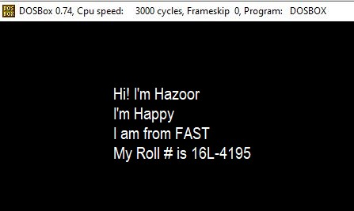

ACTIVITY 2: [50 Marks]

[org 0x0100] jmp code
- equ 70 ; width offset
- equ 50 ; starting x coordinate of line y equ 100 ; starting y coordinate of line
c equ 60 ; color
code: mov ah, 0 mov al, 13h int 10h
; draw diagonal 11:
mov cx, x mov dx, y
mov al, c u1: inc dx
mov ah, 0ch ; put pixel
int 10h inc cx cmp cx, x+w jbe u1
;wait for keypress mov ah,00 int 16h mov ax, 0x4c00 int 21h
Given:
Start with given (𝑥, 𝑦) = (50,100) and in every loop iteration increment both Cx and Dx to reach (𝑥 + 𝑤, 𝑦 + 𝑤) = (120,170).
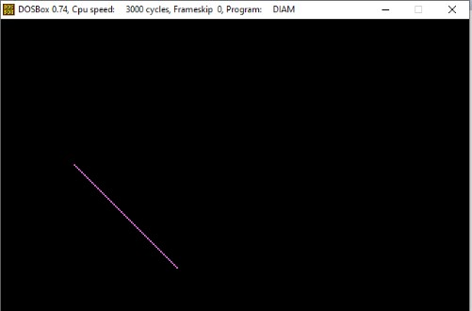⇔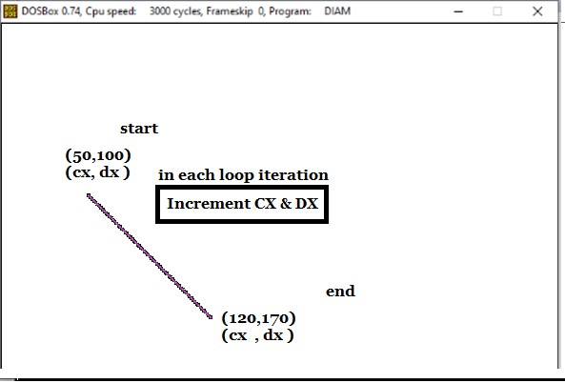
Required:
Similarly, you need to draw 4 lines as above satisfying the coordinates and increment or decrement as per requirement of the line as shown below.
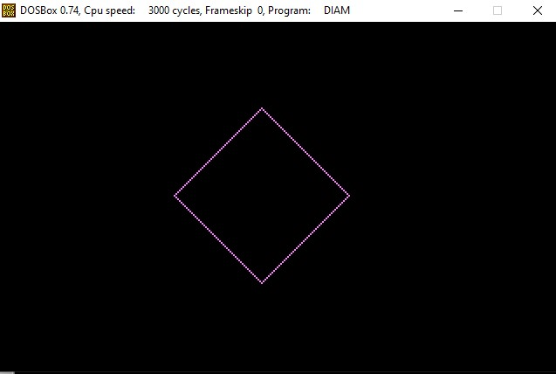⇔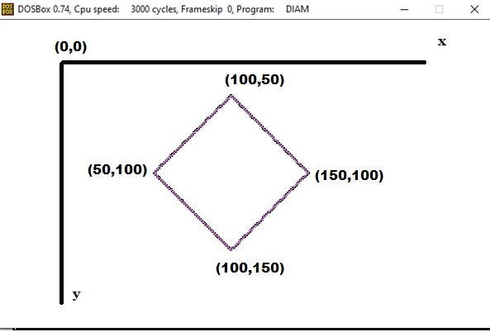

REFERENCES
- https://www.youtube.com/watch?v=ylmCcDf3Oek
- http://www.dosbox.com/download.php?main=1
- http://sourceforge.net/projects/nasm
- http://www.nasm.us/
- http://www.programmersheaven.com/download/21643/download.aspx (AFD)

